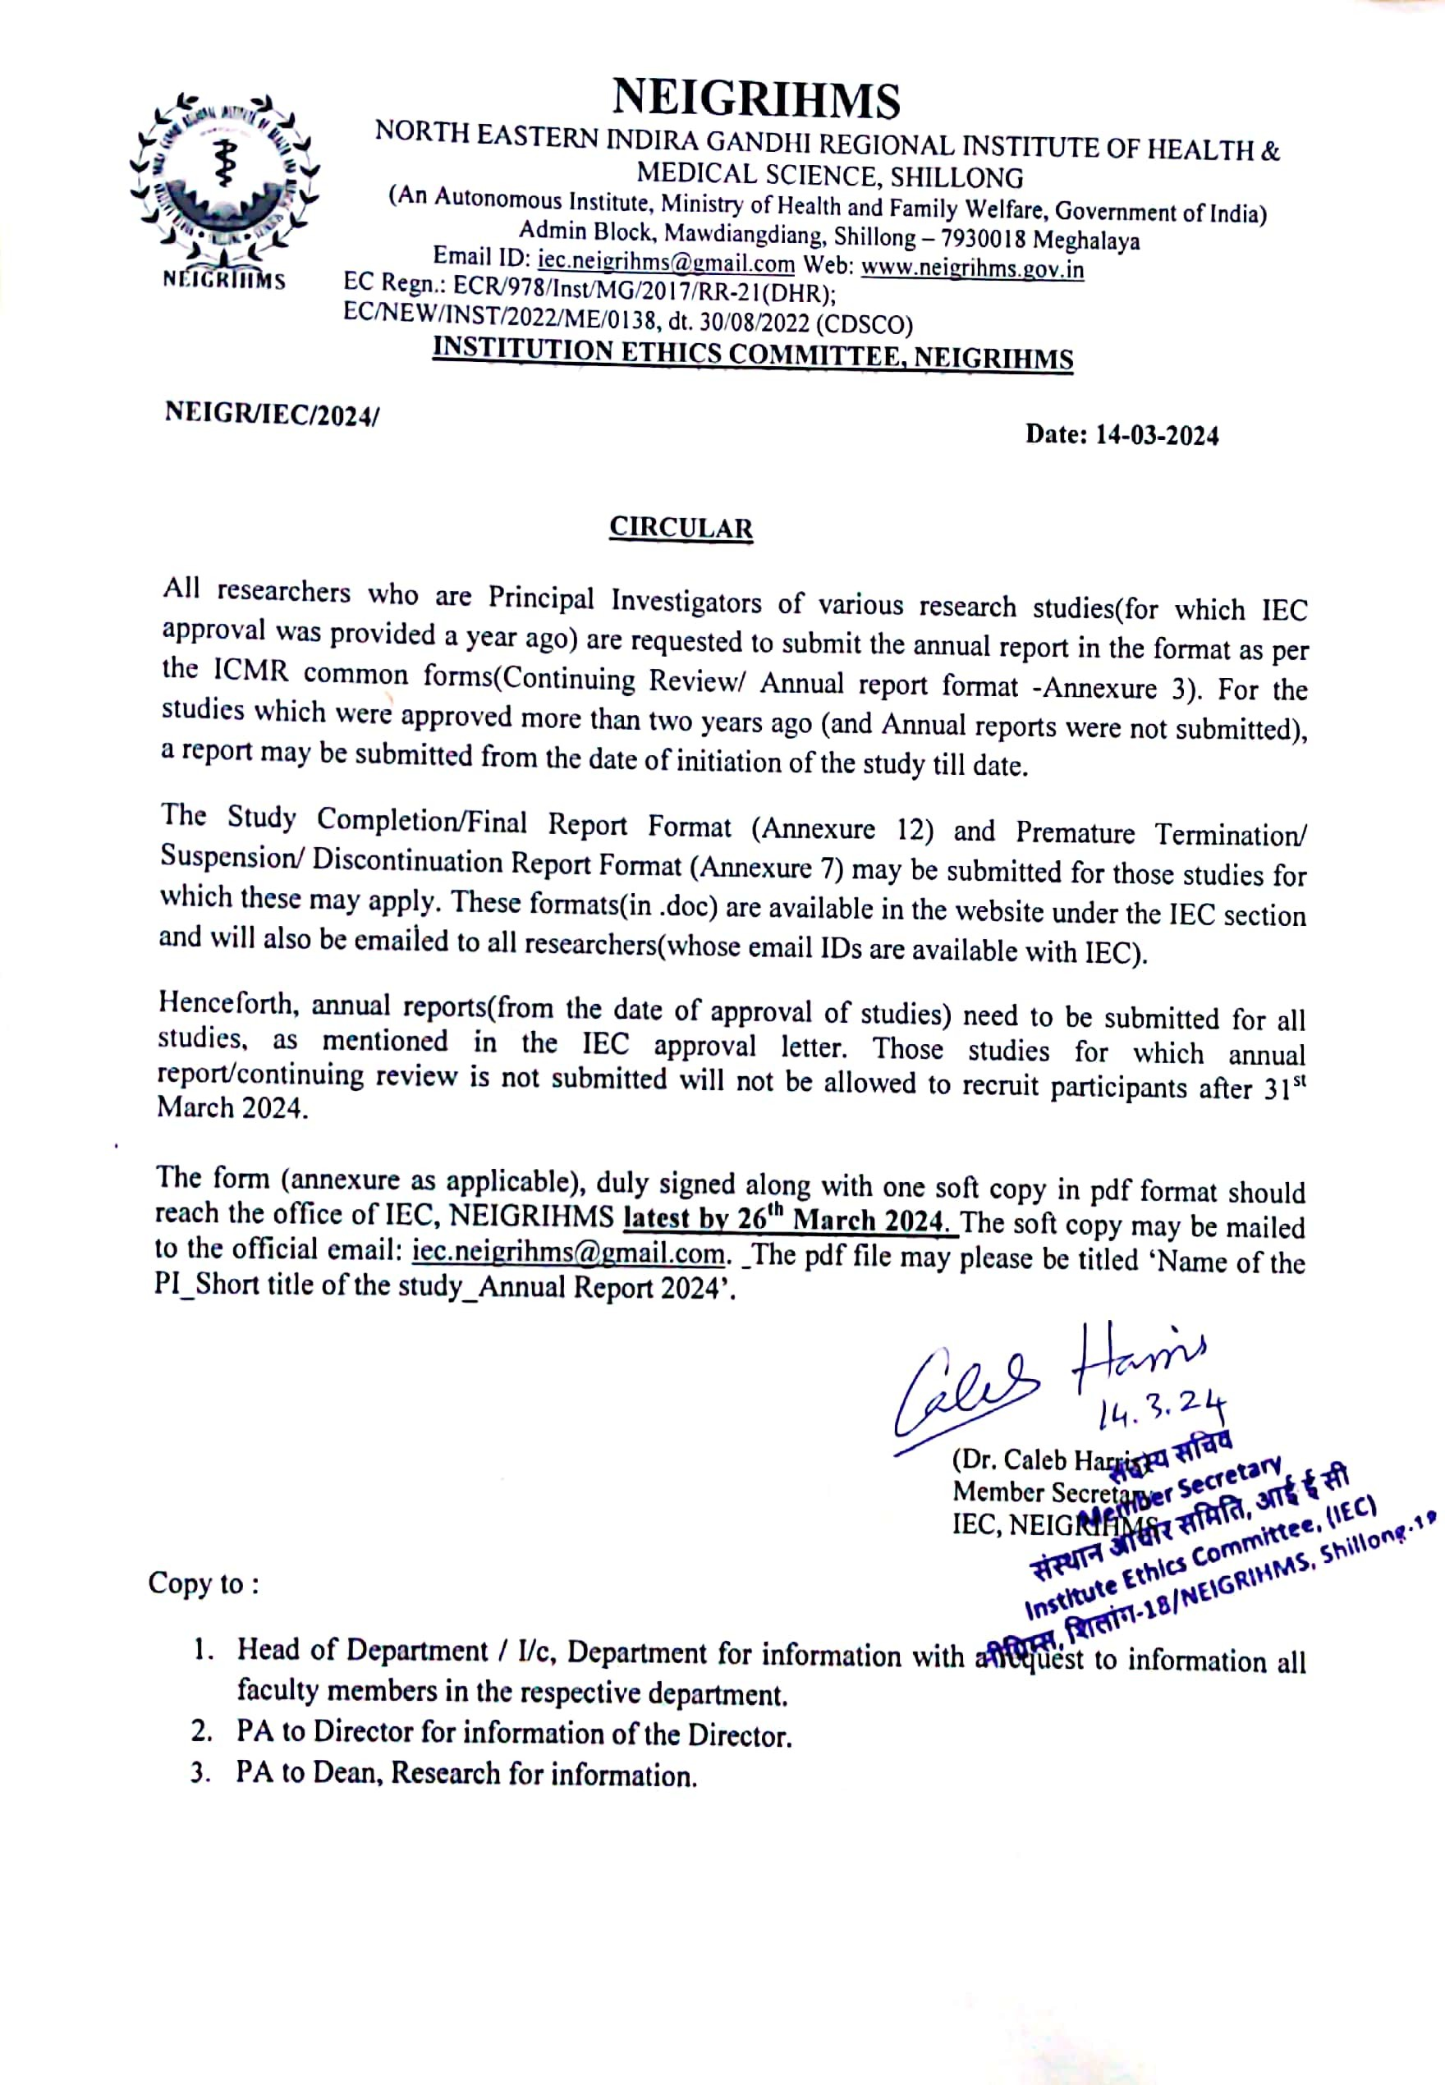

(Annexure 3)
Continuing Review/Annual Report Format
North Eastern Indira Gandhi Regional Institute of Health & Medical Sciences (An Autonomous Institute, Ministry of Health and Family Welfare, Government of
India)
Mawdiangdiang, Shillong (Meghalaya) – 793018 India (www.neigrihms.gov.in) Email id: iec.neigrihms@gmail.com; EC Ref. No.:(for office use)
*The annual report must be duly submitted no later than 30 days before the annual year's completion.
Title of study:

Principal Investigator (Name, Designation and Affiliation):

- IEC Reference No : (Project No.)

- Date of EC Approval: Duration of Approval(months/year):

- Date of Start of study: Proposed date of Completion: Period of Continuing Report: To
- Does the study involve recruitment of participants? (Yes/No):
  - If yes, Total number expected:
No. Screened: No. Enrolled:
  - Enrolment status(ongoing/completed/stopped):
  - Report of DSMB¹⁶ (Yes/No/NA):
  - Any other remark:
  - Have any participants withdrawn from this study since the last approval? (Yes/No/NA): If yes, total number withdrawn and reasons:

- Is the study likely to extend beyond the stated period?¹⁷ (Yes/No): If yes, please provide reasons for the extension:

- Have there been any amendments in the search protocol/informed consent document (ICD) during the past approval period? (Yes/No):
If No, skip to item no. 6
  - If yes, date of approval for protocol and ICD:
  - In case of amendments in the research protocol/ICD, was re-consent sought from participants? (Yes/No):
If yes, when/how:
*Please delete whichever is not applicable.

Version 2.001

¹⁶In case there is a Data Safety Monitoring Board (DSMB)for the study provide a copy of the report from the DSMB. If not write NA.
¹⁷Problems encountered since the last continuing review application with respect to implementation of the protocol as cleared by the EC

Version 2.001

- Is there any new information available that changes the benefits-risk analysis of human participants involved in this study? (Yes/No):
If yes, discuss in details:
- Have any ethical concerns occurred during this period? (Yes/No)
If yes, give details:
- a) Have any adverse events been noted since the last review? (Yes/No):
Described in brief:
b)Have any SAEs occurred since last review? (Yes/No): If yes, number of SAEs: Type of SAEs:
c) Is the SAE related to the study? (Yes/No):
Have you reported the SAE to EC? (Yes/No):
If no, state reasons:
- Has there been any protocol deviations/violations that occurred during this period? (Yes/No):
If yes, number of deviations:
Have you reported the deviations to EC? (Yes/No):
If no, state reasons:
- In case of multicentric trials, whether reports of off-site SAEs have been submitted to the EC (Yes/No/NA):
- Are there any publications or presentations during this period? (Yes/No): If yes, give details:
- Brief summary of the study (up to 500 words) (to briefly described the status, findings, activities undertaken, any deviations or changes, special mentions etc.):

Version 2.002

Signature of PI: Date:

Version 2.003

(Annexure 7)
Premature Termination/Suspension/Discontinuation Report Format
North Eastern Indira Gandhi Regional Institute of Health & Medical Sciences
(An Autonomous Institute, Ministry of Health and Family Welfare, Government of India) Mawdiangdiang, Shillong (Meghalaya) – 793018 India (www.neigrihms.gov.in)
Email id: iec.neigrihms@gmail.com; EC Ref. No.:(for office use)

Title of the study:

Principal Investigator (Name, Designation and Affiliation):

- Date of IEC Approval: Date of start of study:
- Date of Last Progress Report Submitted to EC:
- Date of Termination/suspension/discontinuation:
- Select the appropriate: - PrematureTermination(yes/No/NA):
Suspension (yes/ No/NA) : Discontinuation:(Yes/No/NA):
Reason for Termination/Suspension/Discontinuation:
Action taken post Termination/ Suspension/ Discontinuation:

- Plans for post study follow up/withdrawal²¹(if any):

- Details of study participants:
Total participants to be recruited: Screened: Screen failures: Enrolled:
Consent Withdrawn:
Reason (Give details):
Withdrawn by PI:

Reason(Give details):

Active on treatment: Completed treatment:
Participants on Follow-up: Participants lost follow up:
Any other: No. of drop outs:
Reasons for each drop-out:

Version 2.001

- Total Number of SAEs reported till date in the study:
Have any unexpected adverse events or outcomes observed in the study been reported to the EC? (yes/No)
- Have there been participant complaints or feedback about the study? (Yes/No): If yes, provide details:
²¹Describe post termination/suspension/discontinuation follow up plans if any. Also described any withdrawal plans for the study.

- Have there been any suggestions from the SAE Sub Committee? :(Yes/No) If yes, have you implemented that suggestion? (Yes/No)
- Do the procedures for withdrawal of enrolled participants take into account their rights and welfare? (e.g., making arrangements for medical care of research participants) (Yes/No/NA):
If yes, provide details:

Summary of Results (if any):

Signature of PI: Date:

Version 2.002

(Annexure 12)
Study completion/Final report format
North Eastern Indira Gandhi Regional Institute of Health & Medical Sciences
(An Autonomous Institute, Ministry of Health and Family Welfare,Government of India) Mawdiangdiang, Shillong (Meghalaya) – 793018 India (www.neigrihms.gov.in)
Email id: iec.neigrihms@gmail.com; EC Ref. No.:(for office use)

Title of the study:

Principal Investigator (Name, Designation and Affiliation):

- IEC reference No :(Project No)
- Date of IEC Approval:

- Date of Start of Study: Date of study completion:
Date of Start of Study: Date of study completion:

- Provide details of:
  - Total no. of study participants approved by the EC for recruitment:
  - Total no. of study participants recruited:
  - Total no of participants withdrawn from the study (if any): Provide the reason for withdrawal of participants²³:

- Describe in brief the publication/presentation/dissemination plans of the study findings: (Also, mention if both positive and negative results will be shared):

- Describe the main Ethical issue encountered in the study (if any):

- State the number (if any) of Deviations/violations/Amendments made to the study protocol during the study period

Deviations: Violation: Amendments:

- Describe in brief plans for archival of records/Record Retention:

- Is there a plan for post study follow -up (Yes/No):
If yes, describe in brief:

- Do you have plans for ensuring that the data from the study can be shared /accessed easily? (Yes/No): If yes, describe in brief:

- Is there a plan for post study benefit sharing with the study participants? (Yes/No): If yes, describe in brief:

- Describe results (summary) with Conclusion²⁴:

- Number of SAEs that occurred in the study:
- Have all SAEs been intimated to the EC? (Yes/No):
- Is medical management or compensation for SAE provided to the participants? (Yes/No): If yes, provide details:

Signature of PI: Date

